DBT ASSIGNMENT NO -1

Q.1 creating sample tables and intersecting values
create the following tables with the given strctures and insert sample data as specified :

A)salespeople
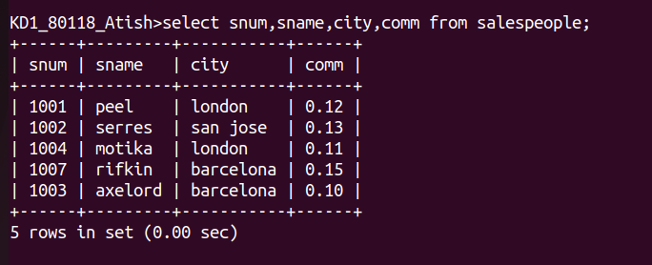

B) customers
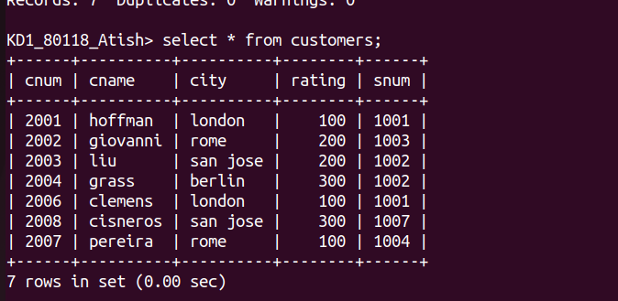
C) Orders

